December 16, 2025
CHAIR |  | VICE CHAIR
SCOTT WIENER |  | JESSE GABRIEL
SENATE |  | ASSEMBLY
BENJAMIN ALLEN |  | DAWN ADDIS
CHRISTOPHER CABALDON |  | DAVID ALVAREZ
JOHN LAIRD |  | STEVE BENNETT
ROGER W. NIELLO |  | HEATH FLORA
ROSILICIE OCHOA BOGH |  | Dr. COREY A. JACKSON
LAURA RICHARDSON |  | JOE PATTERSON
Dr. AKILAH WEBER PIERSON |  | SHARON QUIRK-SILVA

Mr. Joe Stephenshaw, Director
Department of Finance
1021 O Street, Suite 3110
Sacramento, California 95814

Dear Mr. Stephenshaw:

In a letter dated November 26, 2025, you notified the Joint Legislative Budget Committee, pursuant to Control Section 28.00 in the 2025-26 Budget Act, of a request from the Department of Health Care Services (DHCS) to increase its local assistance spending authority by $20,043,000.

In September, the federal Substance Abuse and Mental Health Services Administration informed DHCS that additional, unanticipated funding would be made available for the California 988 Suicide and Crisis Lifeline. The supplemental funds will support enhancements to the 988 programs by expanding the workforce, implementing a comprehensive 988 communication strategy and improving coordination among 988 Crisis Centers, 911, and mobile crisis services.

DHCS reports that California has experienced substantial growth in 988 call volume, averaging more than 52,000 contacts per month from May 2024 through April 2025—an increase of 57 percent since the program’s launch in July 2022. The rising demand for 988 services underscores the need for the additional funding.

To ensure the state can fully encumber the federal resources for 988 programs, I concur with the request and waive the remainder of the 30-day review period.

Sincerely,
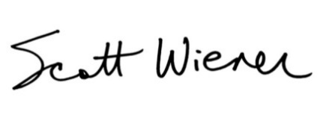
Scott Wiener
Chair

cc: Members of the Joint Legislative Budget Committee

